 **Reference**

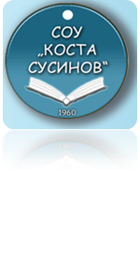**For**

**Zorica Koceva**

**Student in SOU”Kosta Susinov”-Radovish**

I have been working for a long time in the high school "Kosta Susinov" as an English teacher. Zorica Koceva is a student devoted entirely to learning and working tasks. With great love and interest she follows the teaching and shows solid results. In the regular hours, knowledge of material theory overcomes, and in the lessons for additional activities it uses knowledge and emphasizes its creativity and inventiveness. We must be able to help each other, to listen, to exchange experiences and knowledge, to work in a team. Zorica is capable of joining and applying all this. Believe me, she has a lot to offer to others. She is an excellent companion and associate. She is a kind, cultural and talented young person and I think that she would fit perfectly into every company on today's labor market.

I wish the her success in further studies, happiness in employment, and the employers would be proud to have one associate in their company. And I sincerely hope that in future this student will have a bright career.

​**English language teacher**

**Natasha Spasevska**